**Lab 0: Introduction to Software-Defined Radio**

EEP55C26 Open Reconfigurable Networks

Lingyu Gong

1. **Lab purpose**

To gain a thorough understanding of SDR, it is important to experiment with it and apply it to specific communication system applications. One should explore communication signals and study end-to-end communication systems through the software-level definitions of hardware platforms. It is recommended to deploy some of these applications using Pluto SDR to see how the system works.

1. **Spectrum Analyser**

* **Description**

This diagram from MATLAB official website shows the interaction between Simulink, the Pluto Transmitter block, and the radio hardware.

Figure 0 The inner structure.

* **Create the Spectrum Analyser Model**

The picture below shows the module I built according to the tutorial.

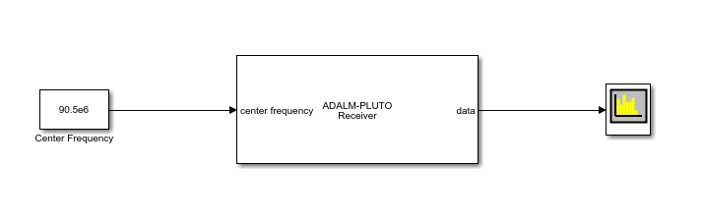

Figure 1 The Spectrum Analyser Model in MATLAB

* **Run the Spectrum Analyser Model**

The following results were obtained after running the module, with the specific parameters listed below: centre frequency of 92.0e6 Hz, gain of 50 dB, and baseband sample rate of 2e6 Hz.

Figure 2 Result 1 from example

* 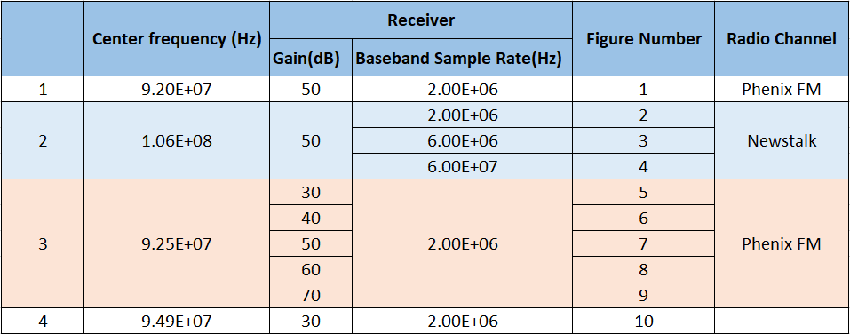**Comparison of different parameters**

Table 1 Table to show different parameters.

Figure 2 through Figure 4 will display the differences between various baseband sample rates while keeping all other parameters constant and only varying the baseband sample rate. Figure 5 to Figure 9 will represent how the Gain change will affect the result.

Figure 2 displays the results obtained with the following parameters: a centre frequency of 106.0e6 Hz, a gain of 50 dB, and a baseband sample rate of 2e6 Hz. Additionally, it demonstrates a broader bandwidth compared to others.

Figure 2

Figure 3 shows the results with the specific parameters listed below: centre frequency of 106.0e6 Hz, gain of 50 dB, and baseband sample rate of 6e6 Hz.

Figure 3

Figure 4 shows the results with the specific parameters listed below: centre frequency of 106.0e6 Hz, gain of 50 dB, and baseband sample rate of 6e7 Hz.

Figure 4

As can be seen from the above example, as the Baseband Sample Rate increases, the abscissa will cover more frequency ranges.

Next, the influence of another parameter Gain will be shown. The following images 5 to 9 all accept 92.5MHz, and the Baseband Sample Rate remains unchanged at 2MHz.

In addition, to make the results more obvious, I marked the position with the highest energy in each graph.

Figure 5 Gain = 30

Figure 5-1 Annotated image (Gain = 30)

Figure 6 Gain = 40

Figure 6-1 Annotated image (Gain = 40)

Figure 7 Gain = 50

Figure 7-1 Annotated image (Gain = 50)

Figure 8 Gain = 60

Figure 9 Gain = 70

Finally, after trying some channels, I found one that showed better results and showed it. For this graph, the parameters will be Centre Frequency 94.9 MHz, Gain as 30 dB, Baseband Sample Rate as 2MHz.

Figure 10 Present a good result.

1. **Parameters Analysis**

Figure 11 Description of the Parameters

1. **Summary**

During the experiment, I was able to achieve several important milestones. Initially, I conducted preliminary debugging of the instrument and ensured that it was both functional and reliable. This step was crucial in establishing a stable connection between the instrument and the MATLAB programming software which was essential for subsequent experimental procedures.

Furthermore, I gained a comprehensive understanding of the platform required for conducting future experiments. This involved understanding the significance of basic parameters, mastering their practical application, and evaluating their potential impacts on the experiment's outcomes. My proficiency with the platform has significantly improved, enabling me to use it more effectively in experimental contexts.

In addition, the experiment provided me with a deeper insight into wireless systems. Through hands-on experience and observation, I have developed a nuanced understanding of their operational principles, challenges, and potential applications. This knowledge is invaluable for my ongoing research and experiments.

As a result of my enhanced skills and understanding, I am now well-positioned to conduct more complex experiments, perform insightful analyses, and make informed summaries.

1. **Appendix**

Content from website.

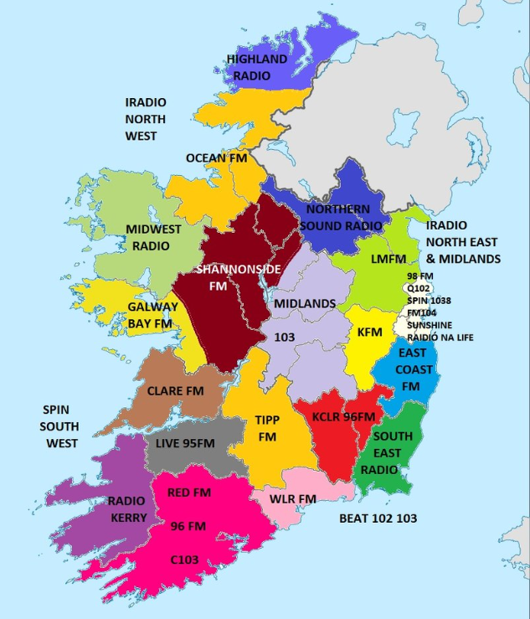

Figure 12 Map of regional and local stations in the Republic of Ireland